Homework 5

1)

a) Vertex connectivity for the Kn complete graph k(G) is n-1 where n>2

Edge connectivity for the complete graph k’(G) is n-1

b) Vertex connectivity for the cycle graph k(G) is 2

Edge connectivity for the cycle graph k’(G) is 2

c) Vertex connectivity for the complete bipartite graph(Kn,m) k(G) is =minimum(n,m)

Edge connectivity for the complete bipartite graph(Kn,m) k’(G) is =minimum-degree(G) or minimum(n,m)

d) Vertex connectivity for the cube graph (Qr) k(G) is r

Edge connectivity for the cube graph (Qr) k’(G) is r where r>1

2)

(6.8)

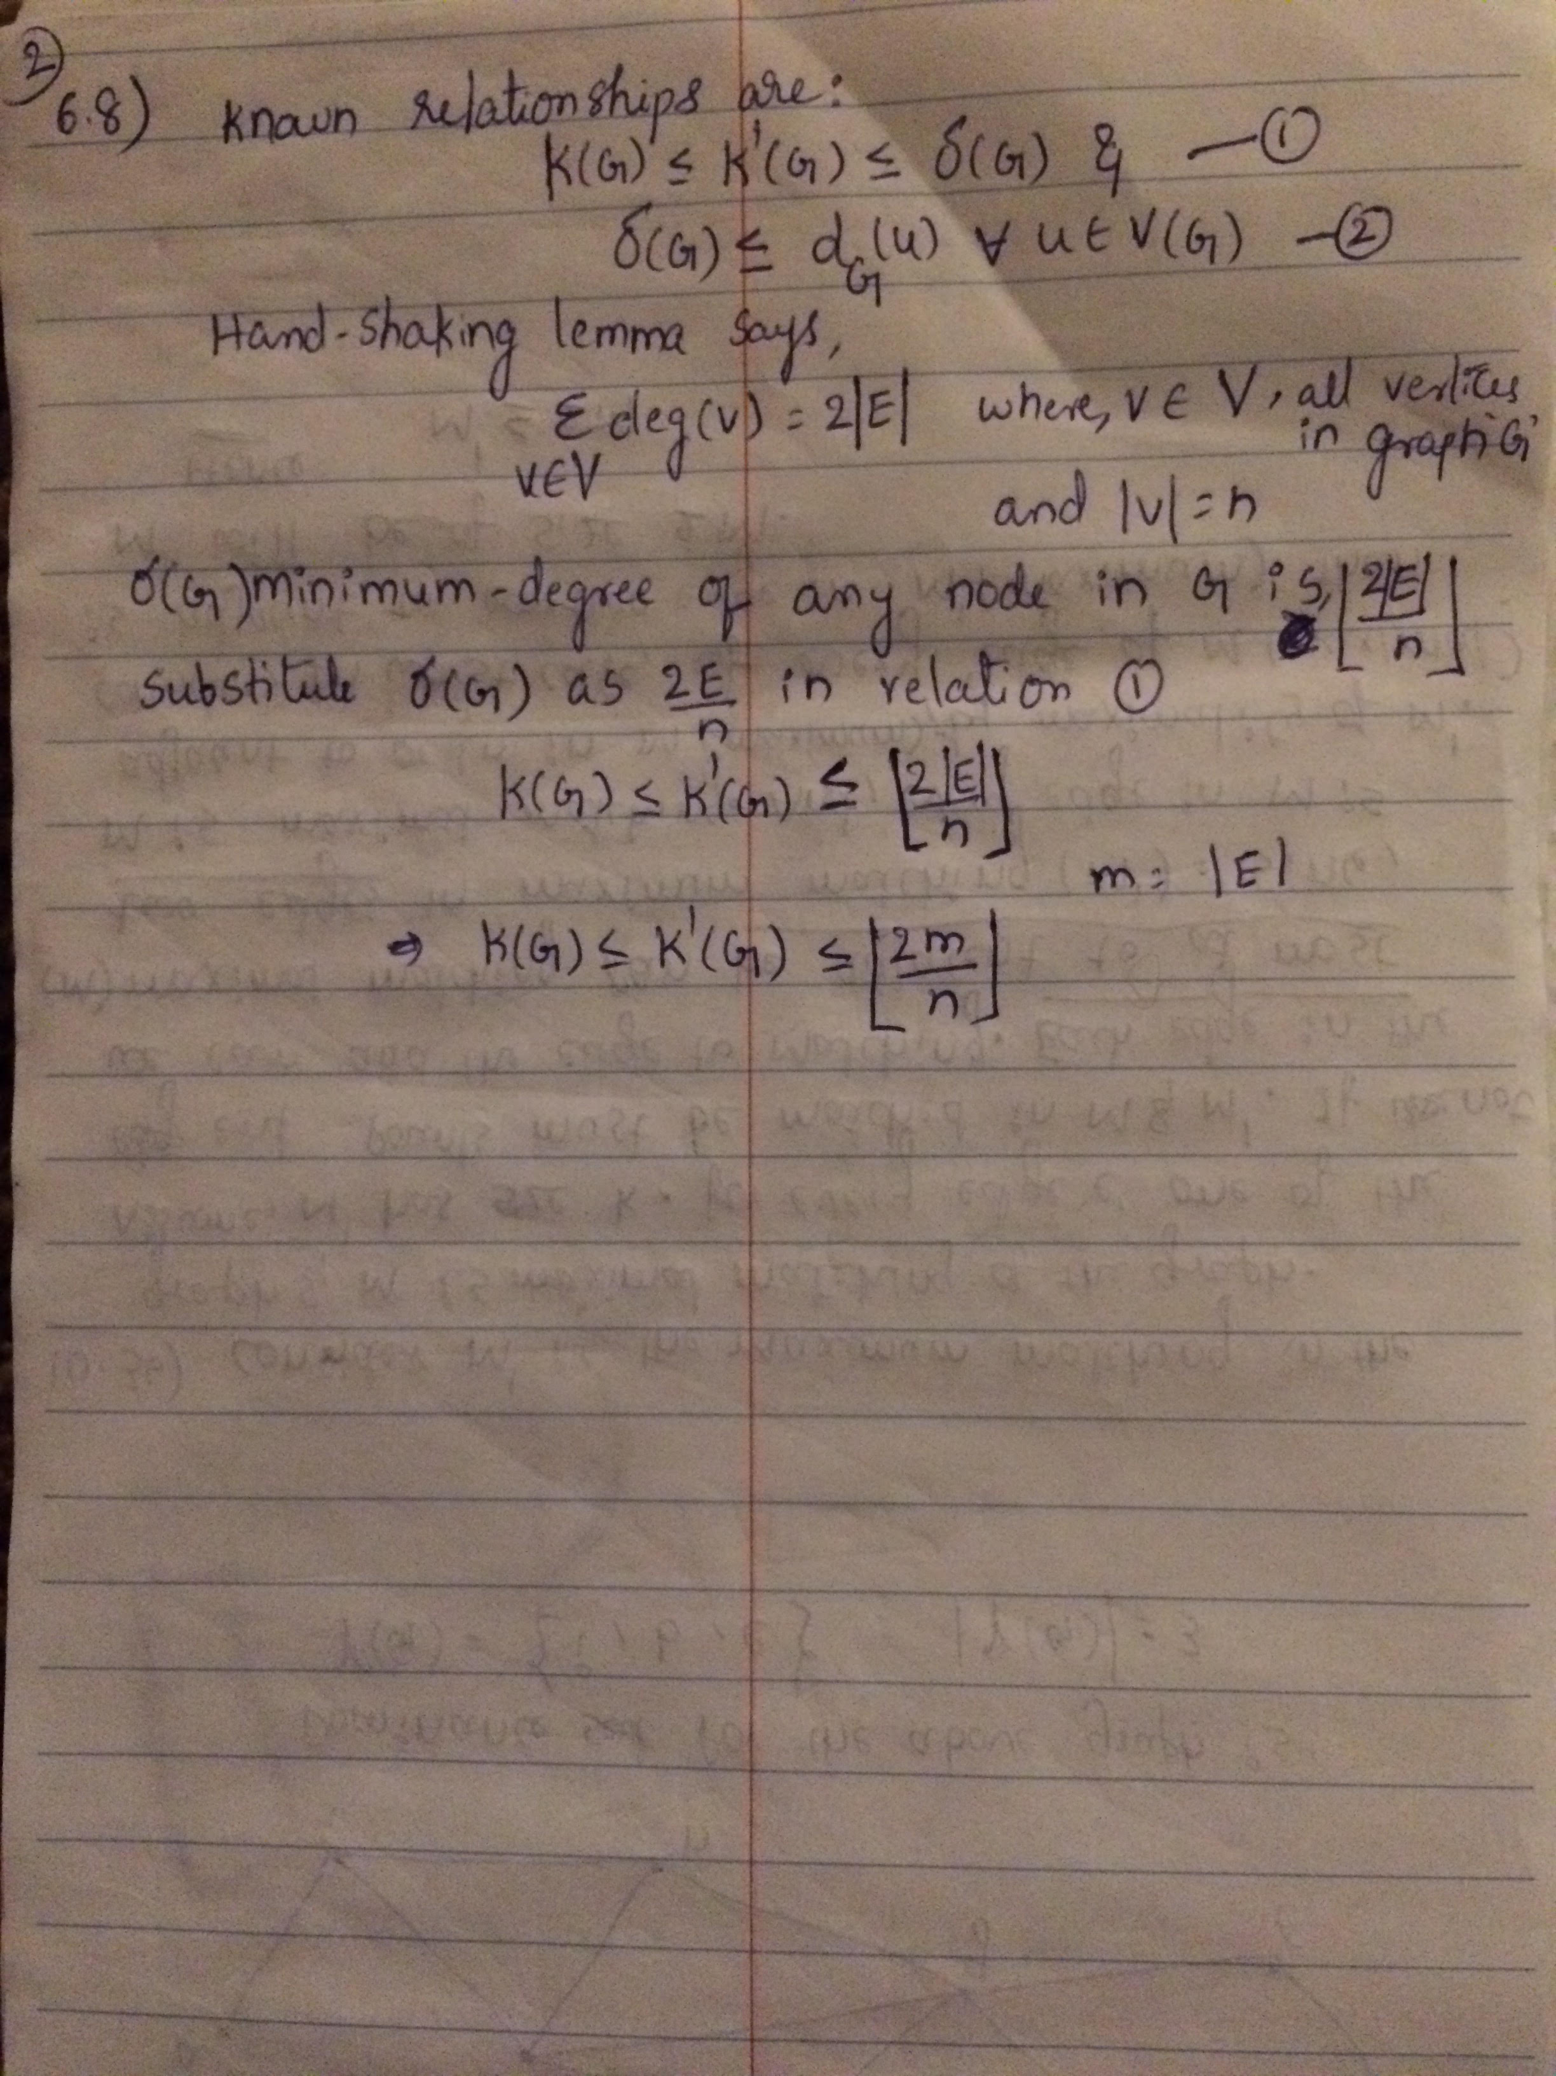

6.33)

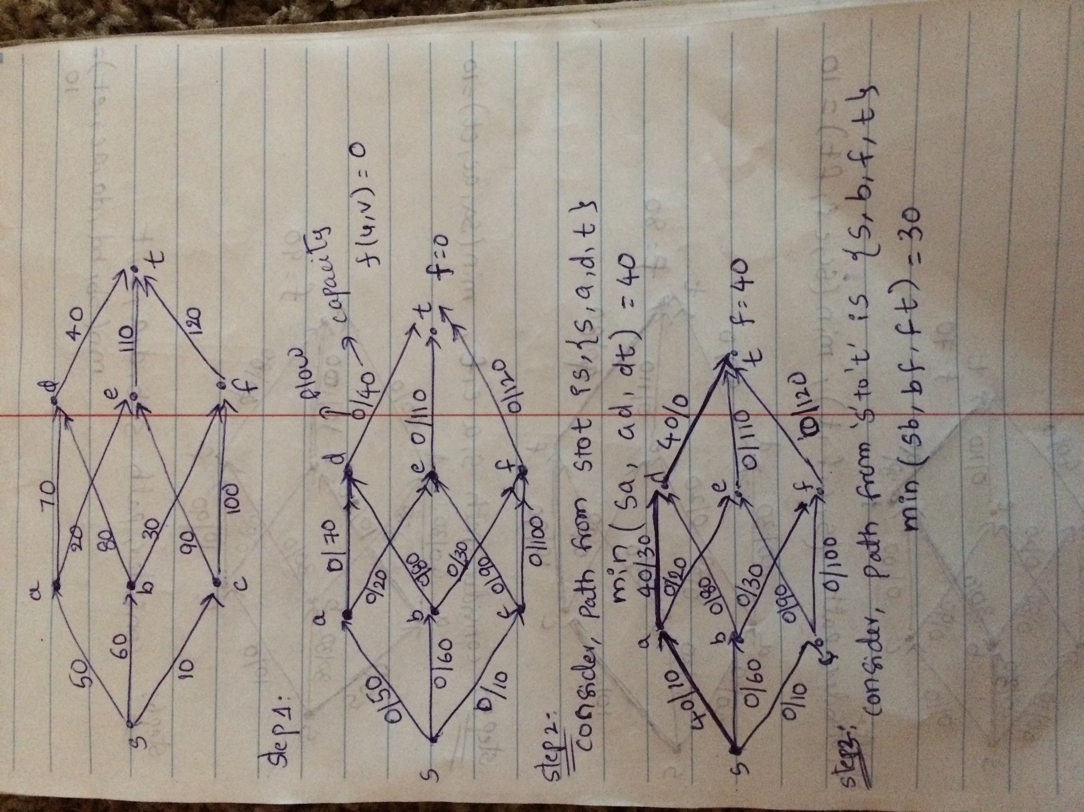

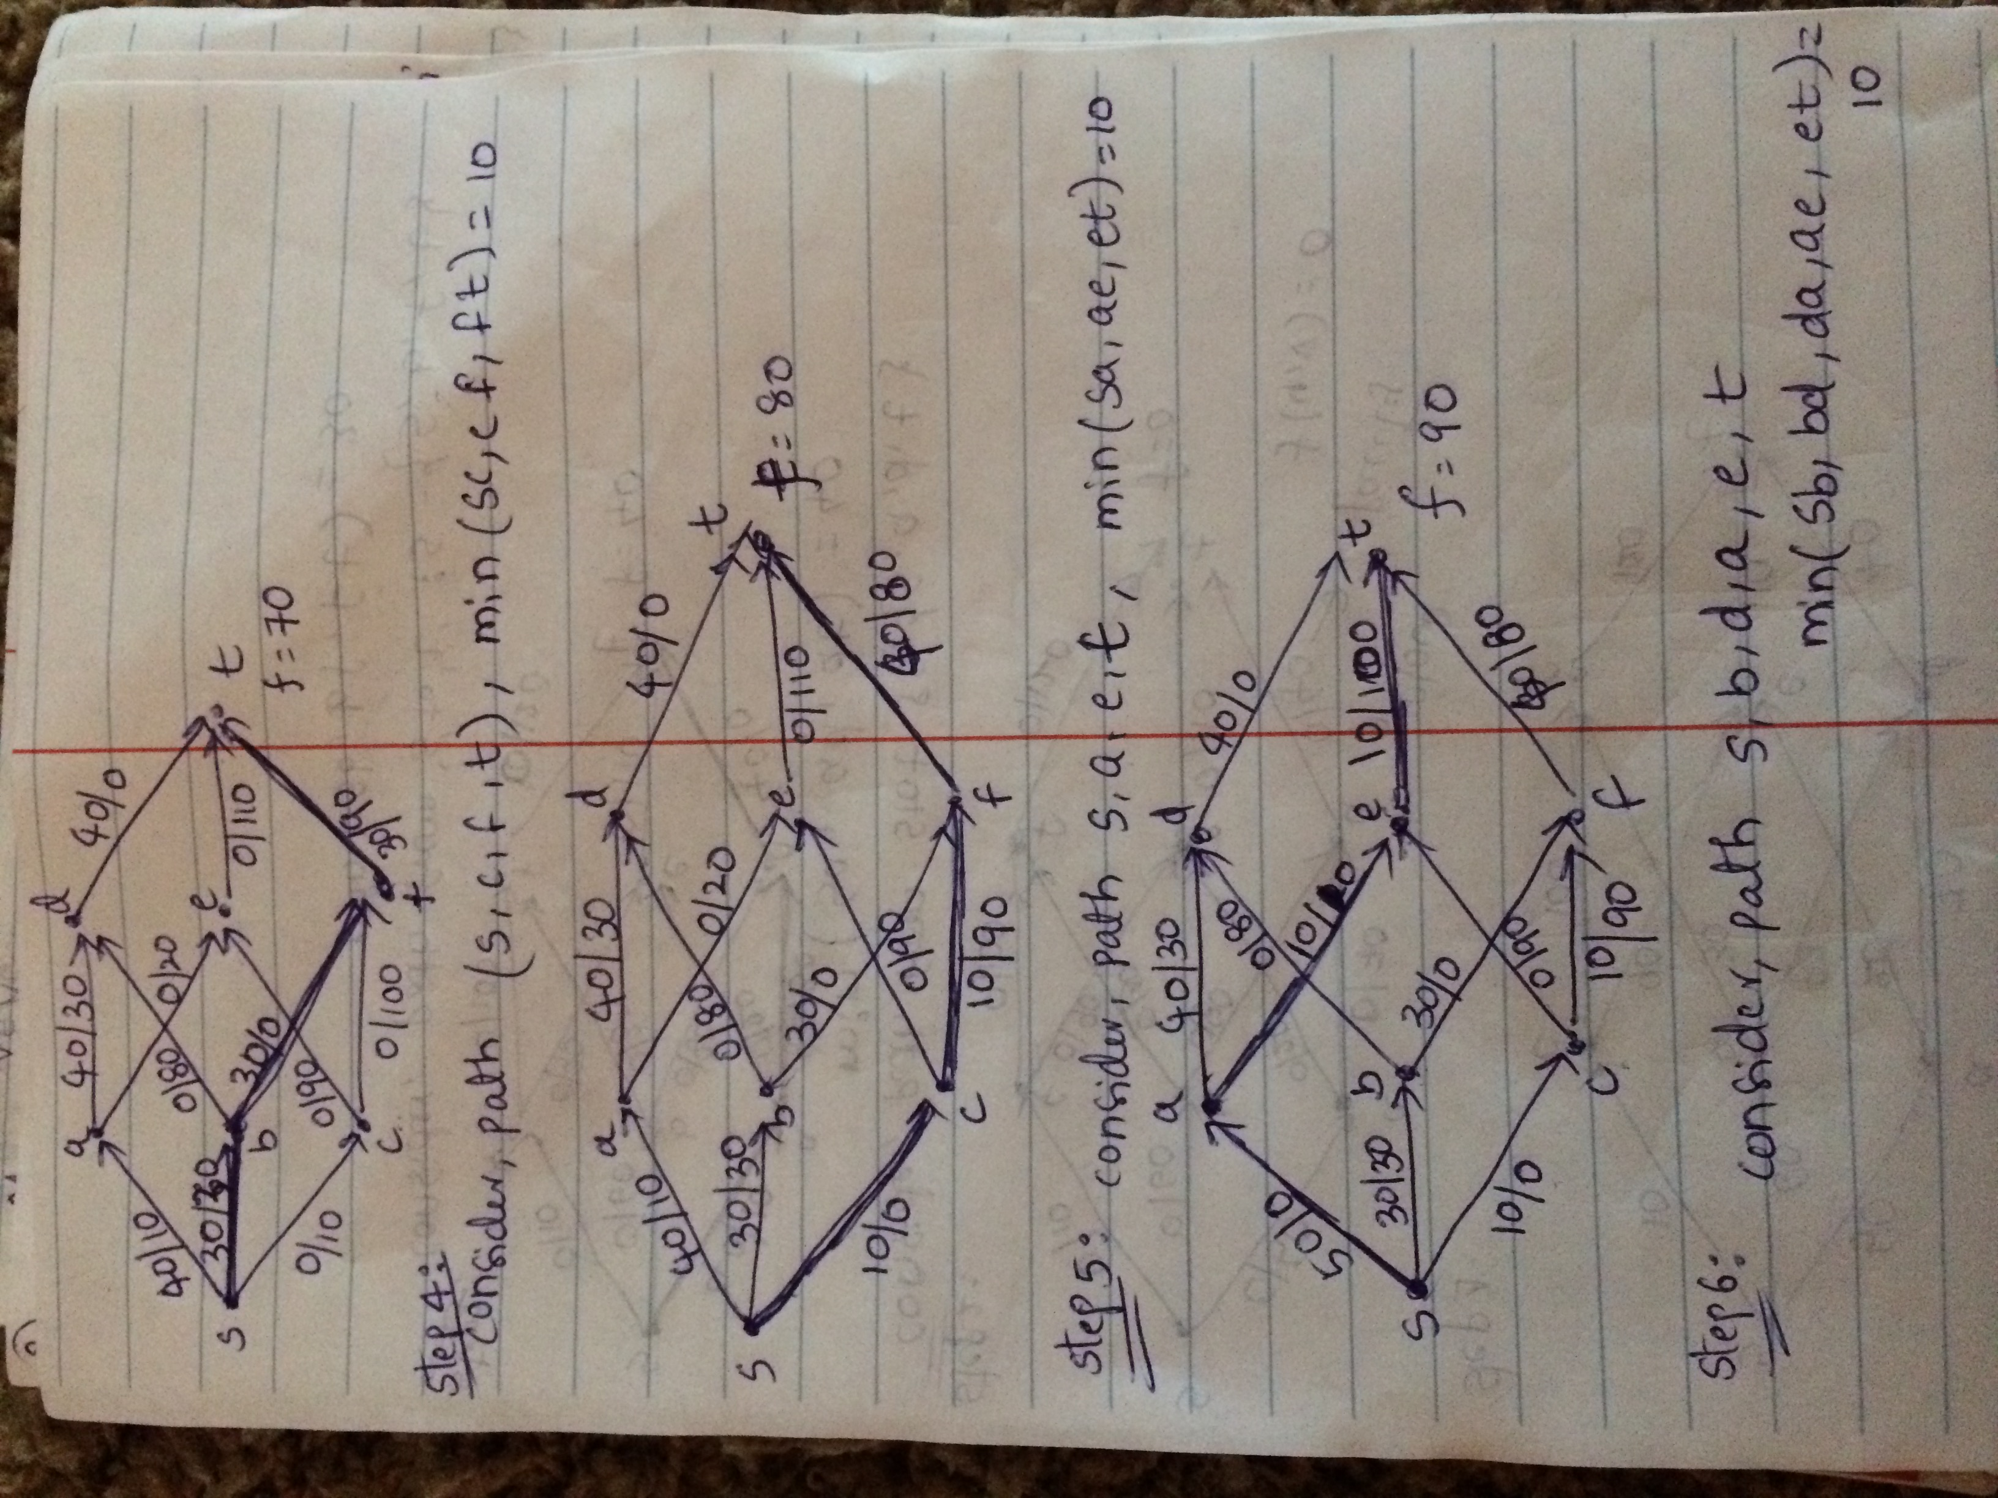

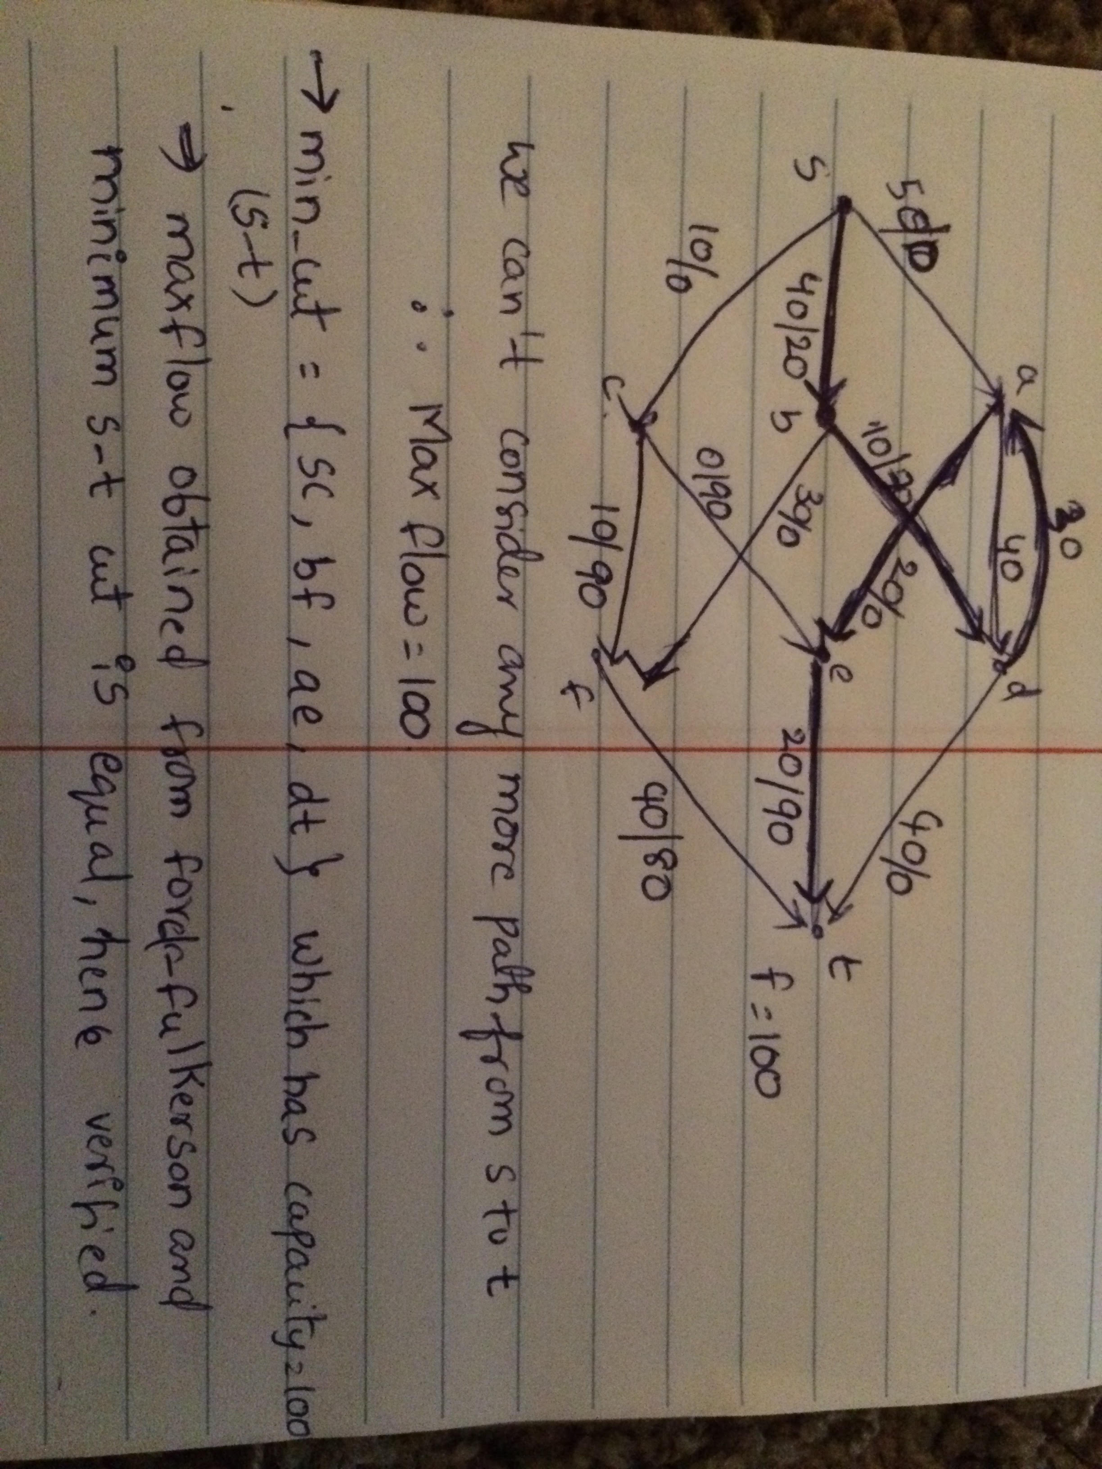

3)

a) We can model this problem into undirected graph with n nodes and m edges, G(V,E) where |V|=n and |E|=m. In the graph, nodes represent the corners and edges represents streets.

b) Vertex cover for the graph can be used to solve the problem. A vertex cover number for the graph gives the minimum number of cameras required for covering all streets. Vertex cover on a graph is A set of nodes L in a graph G = (V,E) is a vertex cover if every edges in E(G) has an endpoint in L.

The vertex cover number *beta (G)* of a graph G is the number of nodes in one of G’s minimum vertex covers.

c) Minimum number of cameras need in the following graph is, minimum vertex cover on the graph. Minimum vertex cover is beta (G)= {E, B, C, F}.

That is, |beta (G)|=4.

Number of cameras needed is to cover all edges is 4.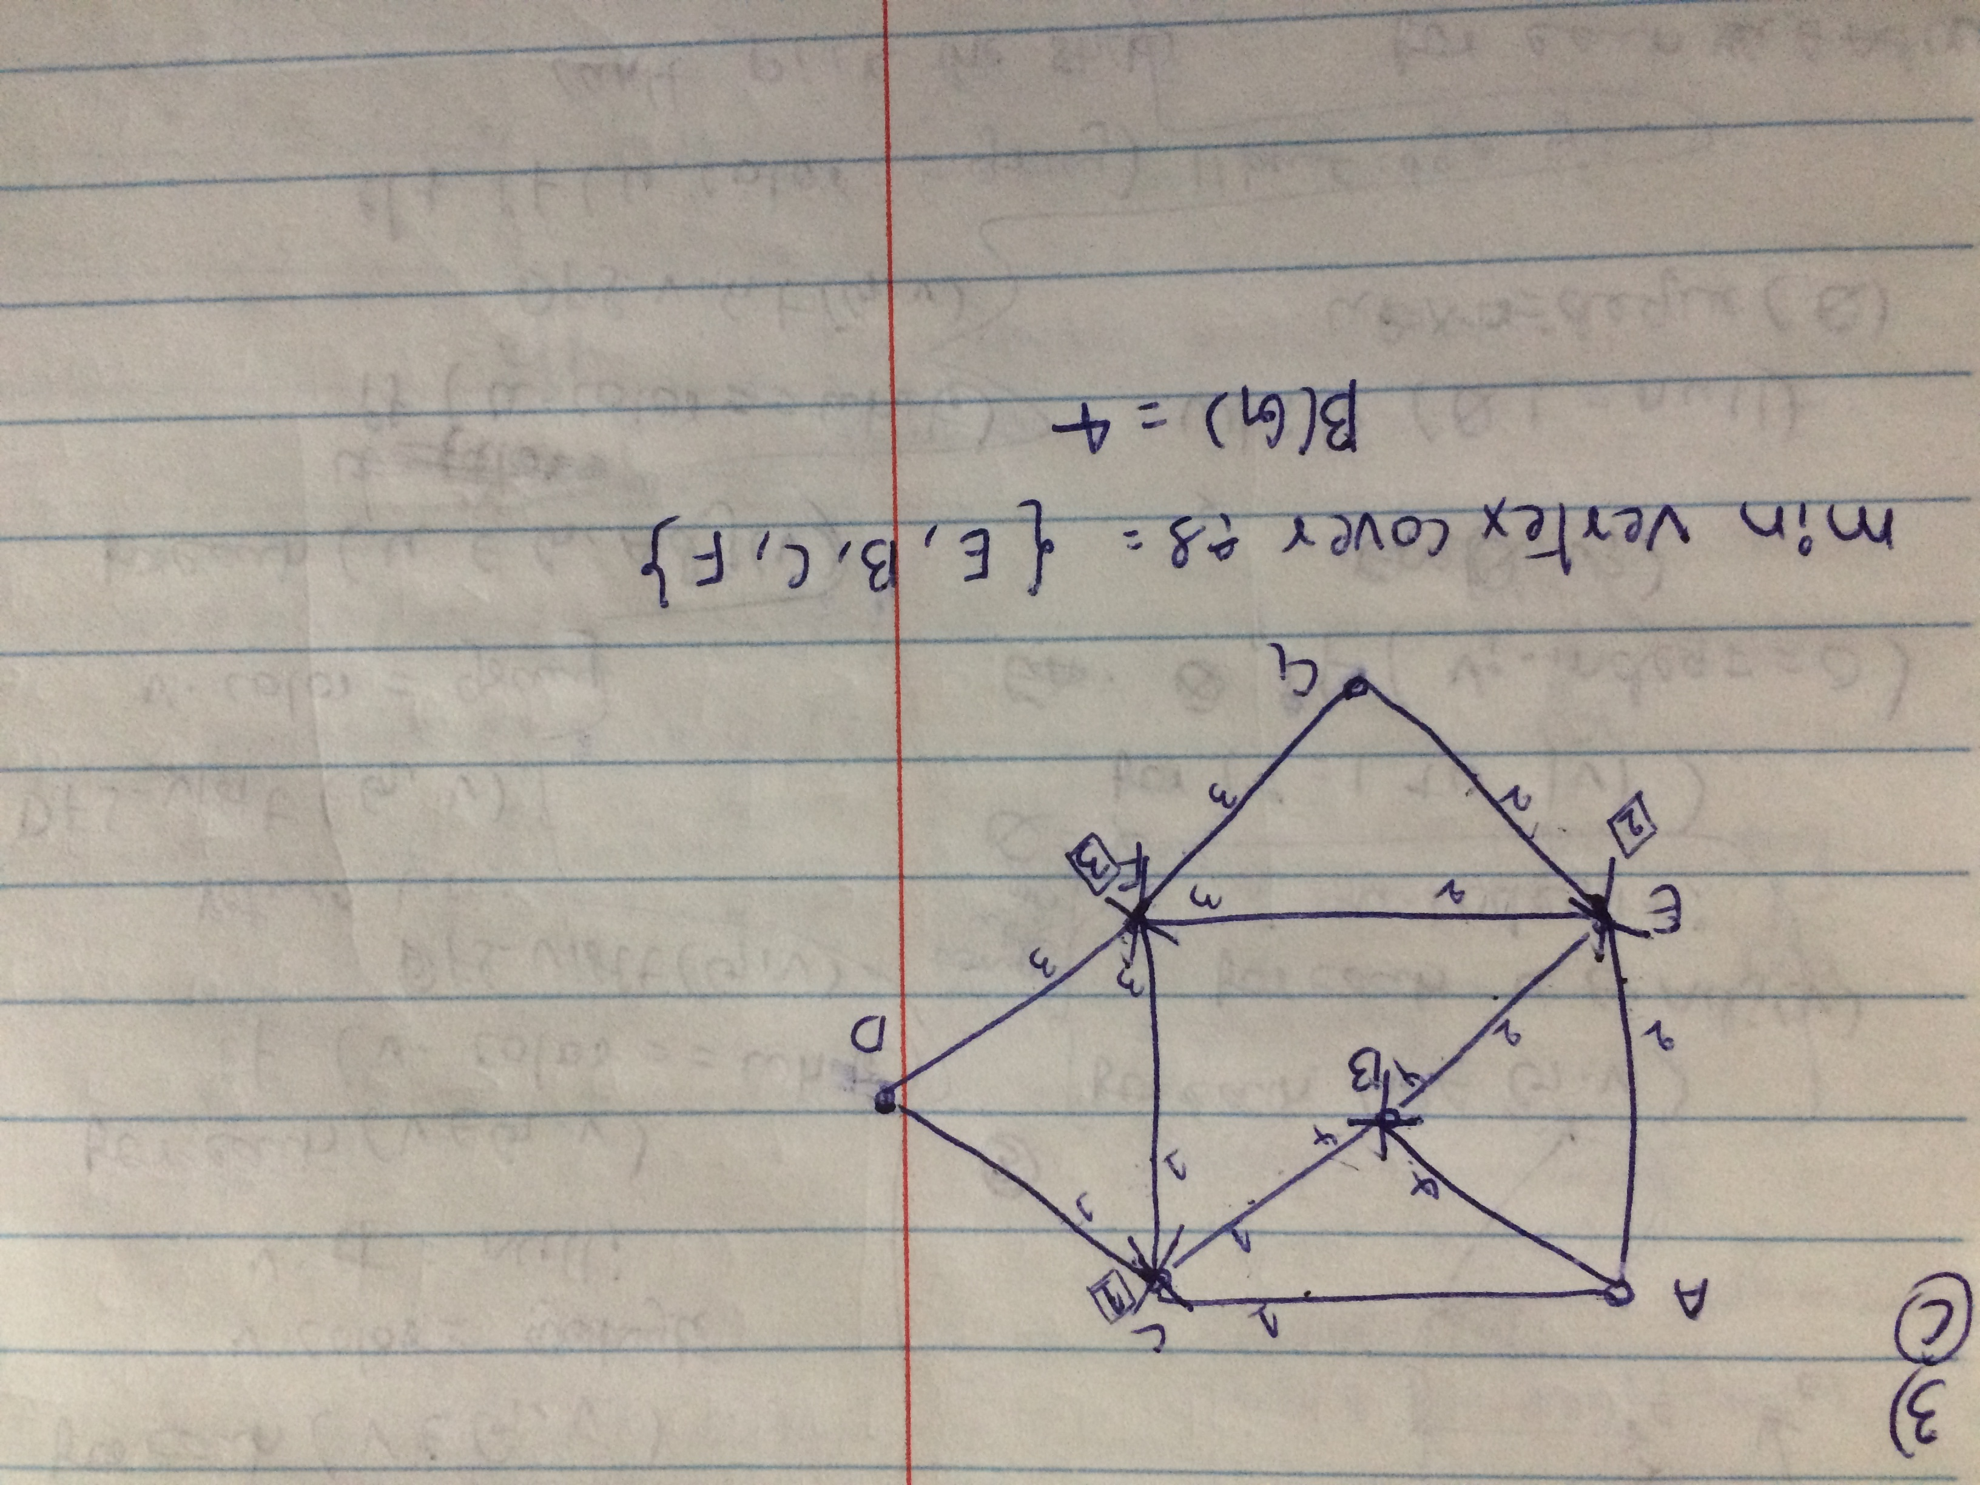

4)

a) Complement graph is:

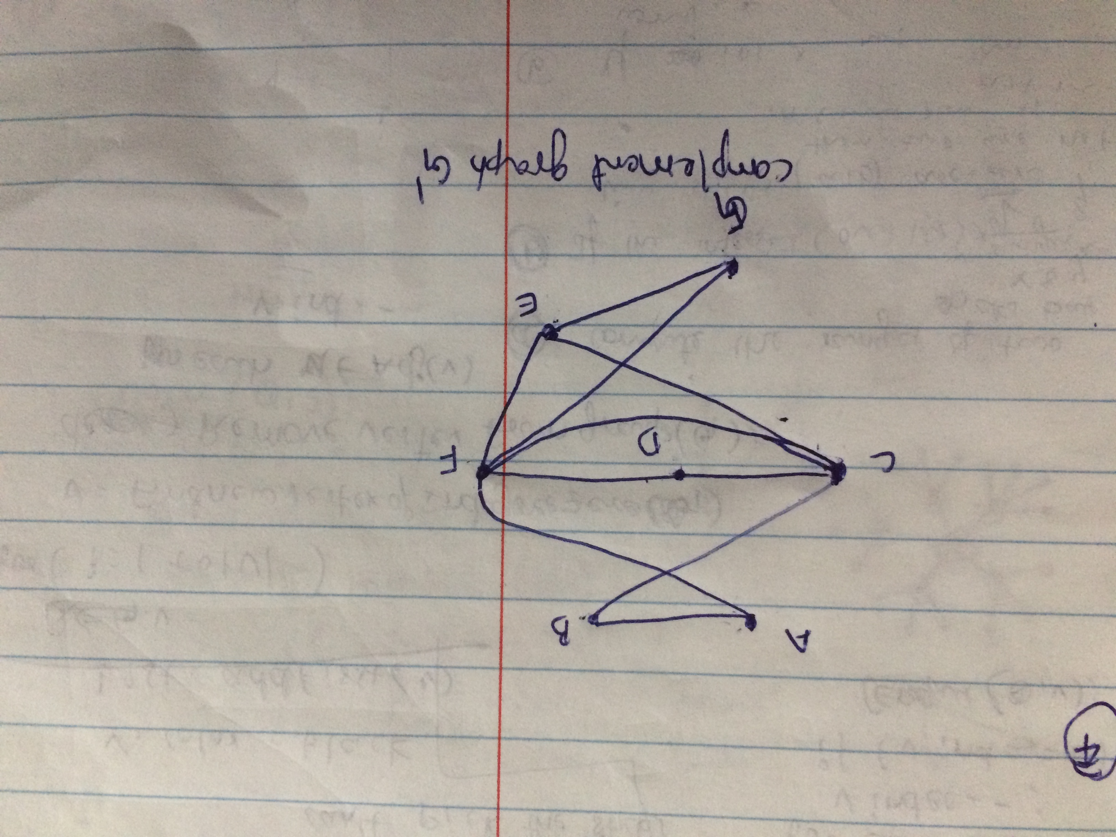

b&c)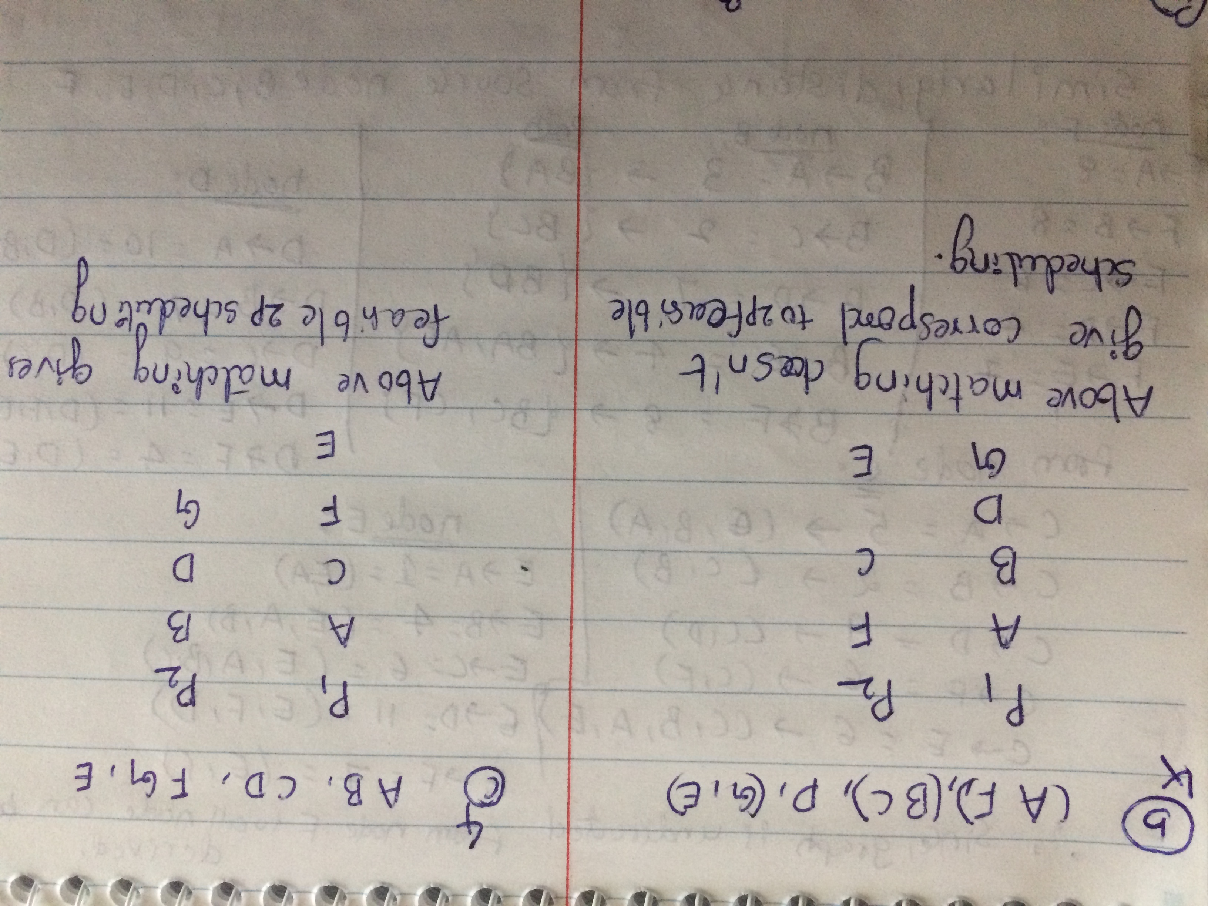

d) No of edges in matching are 3. Where, matching in the graph is M={AC, DG, BG} and feasible schedule S={AB, CD, FG, E} is 4. No of nodes (n) in the graph are 7.

The relationship, S=n-|M|

=7-3🡺4

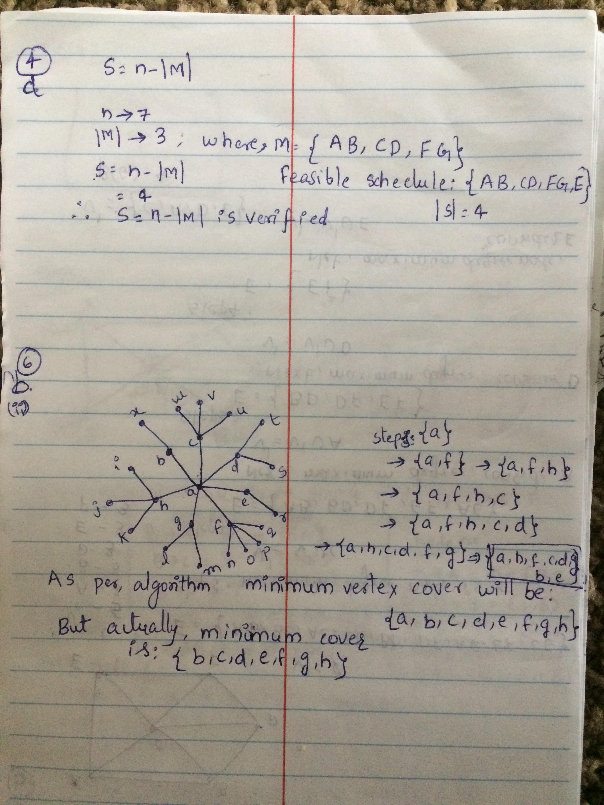

5) The Prims algorithm searches for the minimum spanning tree, only cares about the minimum of the total edges cover all the vertices. so it looks like: v.key = w(u,v) The Dijkstra’s, which searches for the minimum path length, so it cares about the edge accumulation. So it looks like :v.key = w(u,v) + u.key.

In the Prims algorithm cost to reach each node is calculated from minimum weighted edge from its neighbor node. This does not include path cost from the source node. If the minimum path cost from source is calculated on each edge it will be turned in Dijkstra’s algorithm.

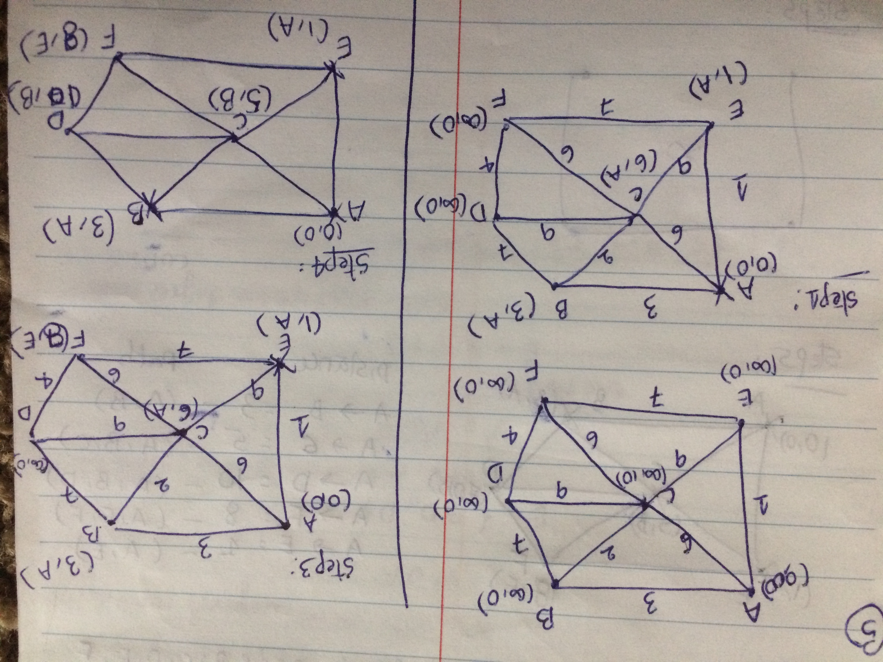

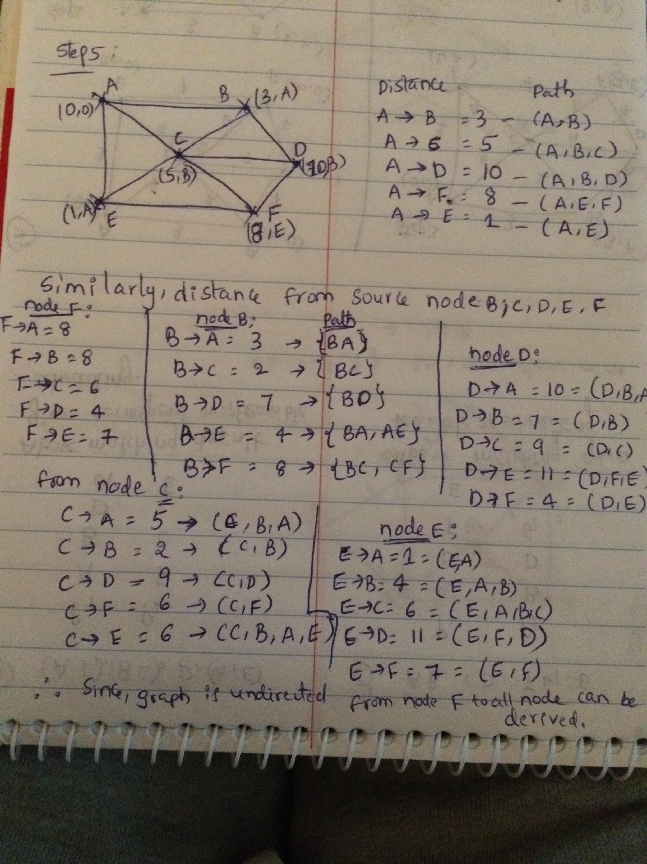

6) (a)

This heuristic always finds a vertex cover. Heuristic, in each iteration it adds highest degree node to vertex cover set, which covers all edges associated with it. Since, it will add vertices to vertex cover set until all edges are covered. Once all the edges are covered, it will return vertex cover set. So, all edges will be covered that defines feasible vertex cover set. But this heuristic doesn’t always give minimum vertex cover.

(b) For below graph algorithm computes efficient vertex cover.

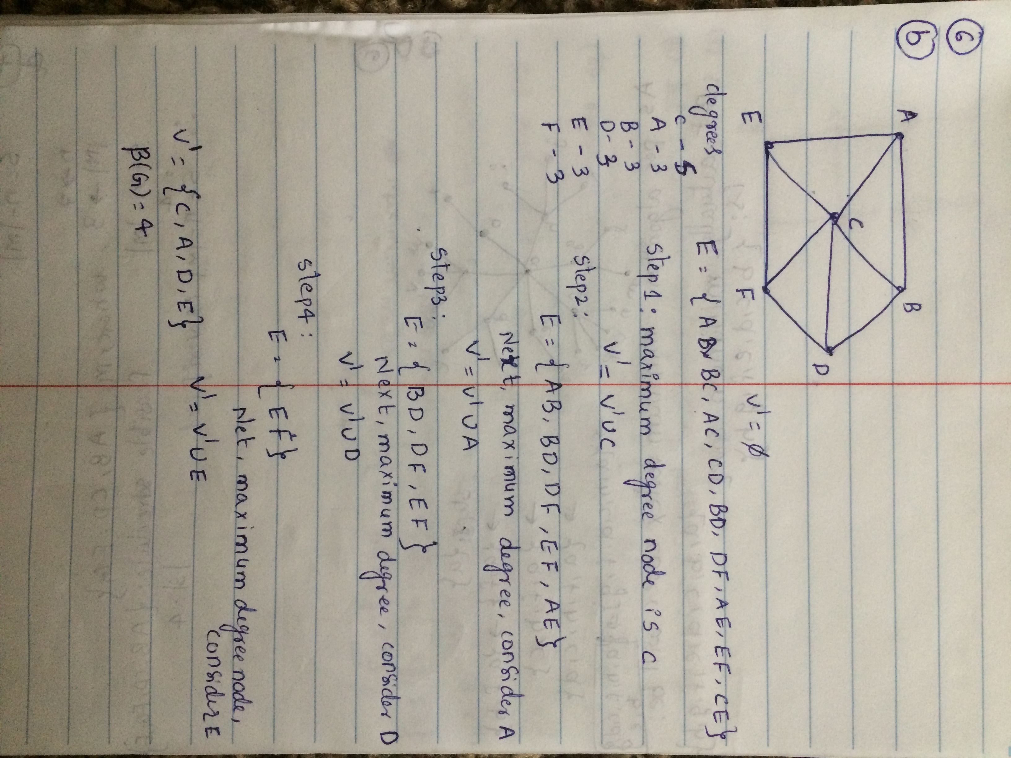

b) For below graph algorithm does not computes minimum vertex cover.

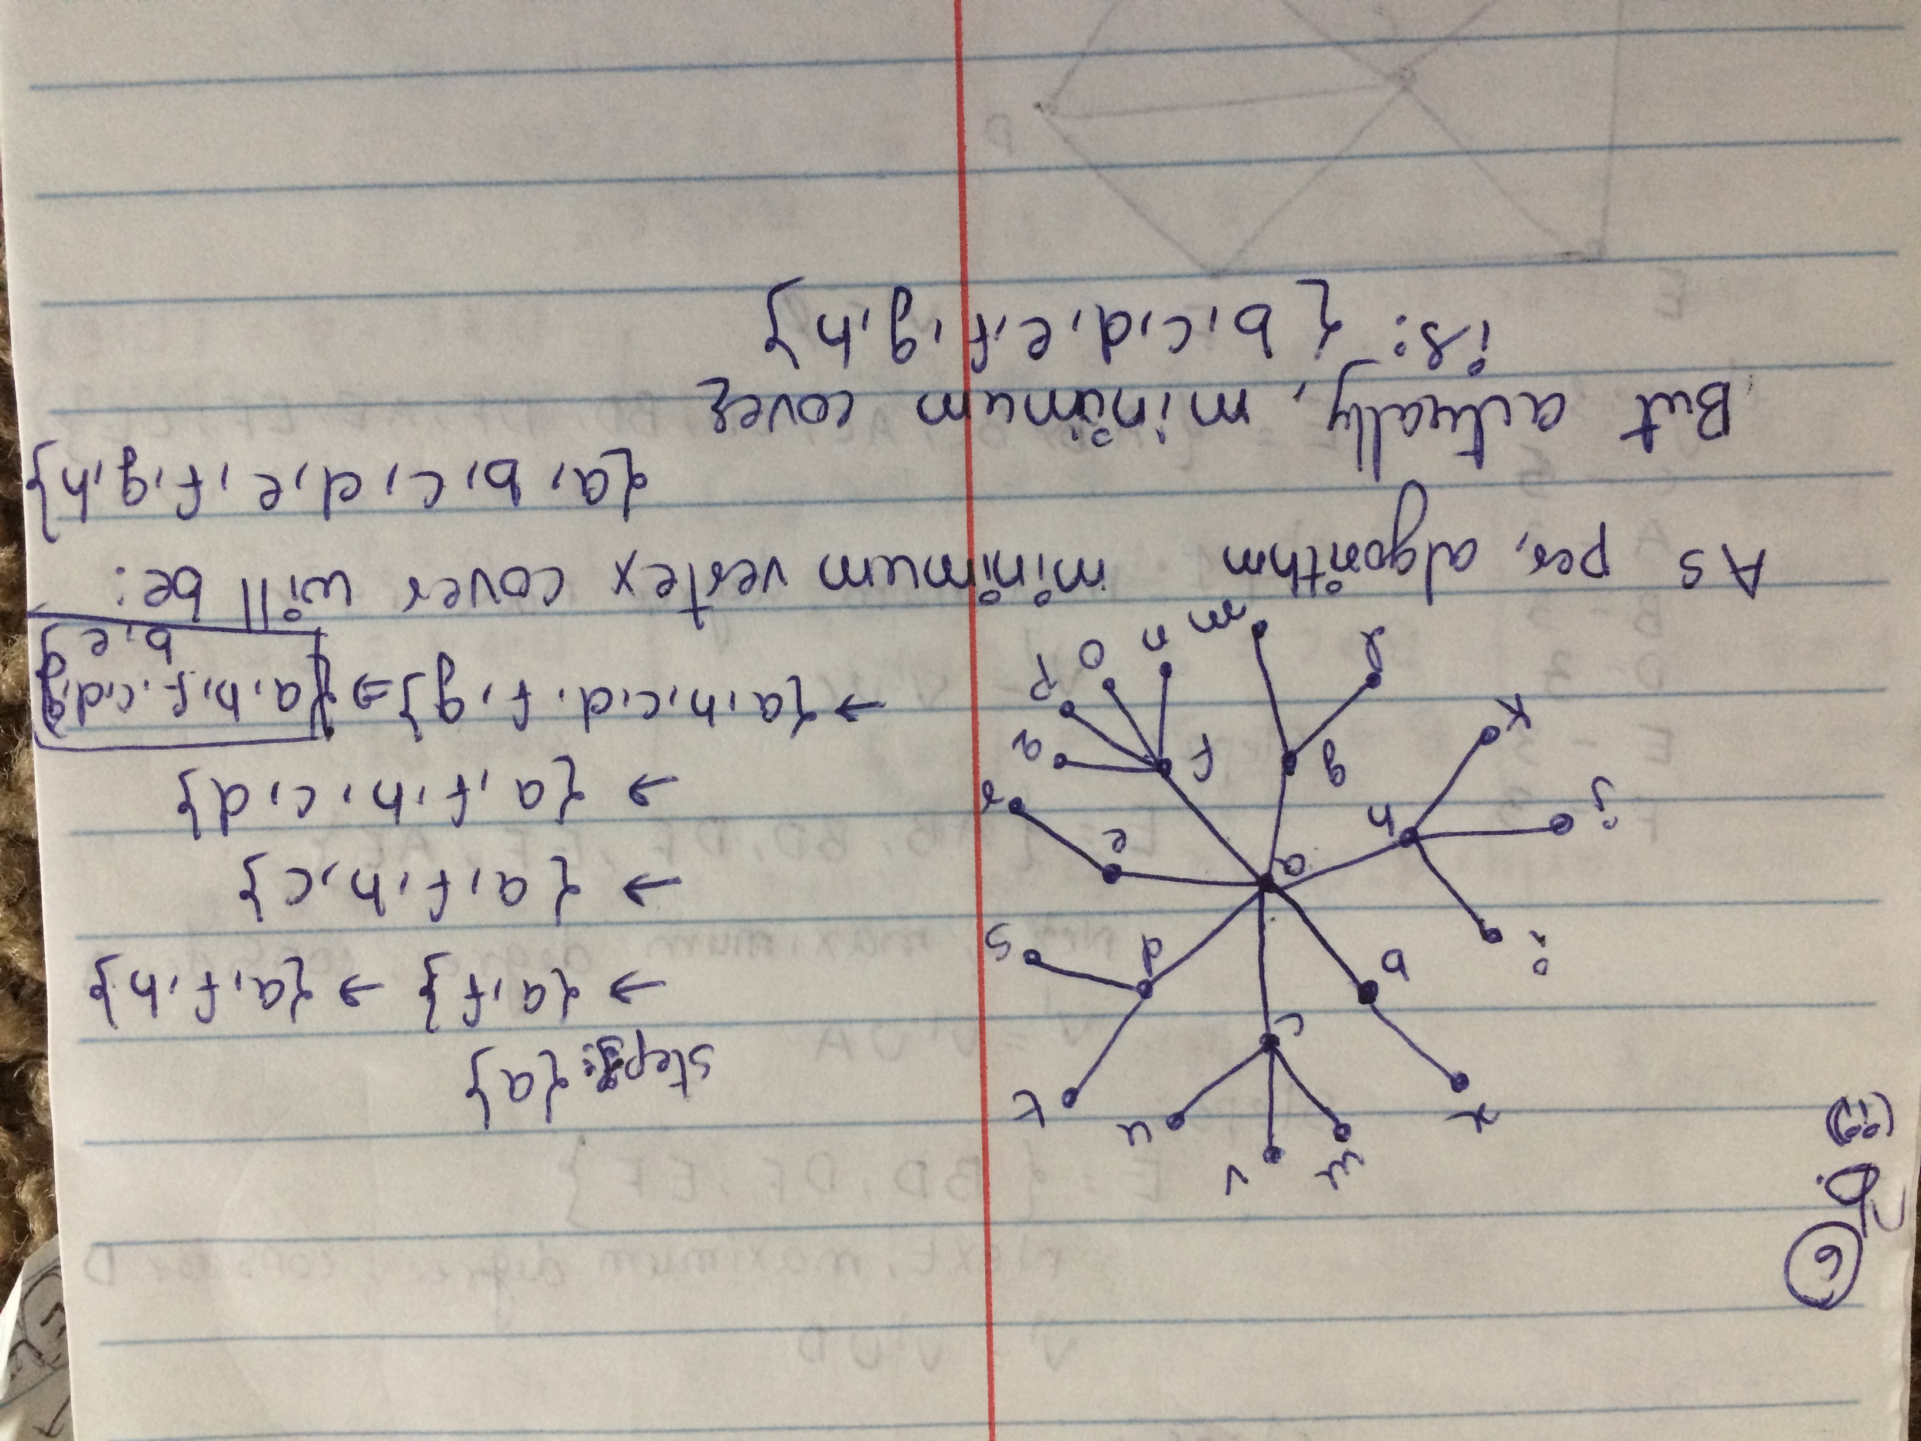

7)

(10.11 & 10.36)

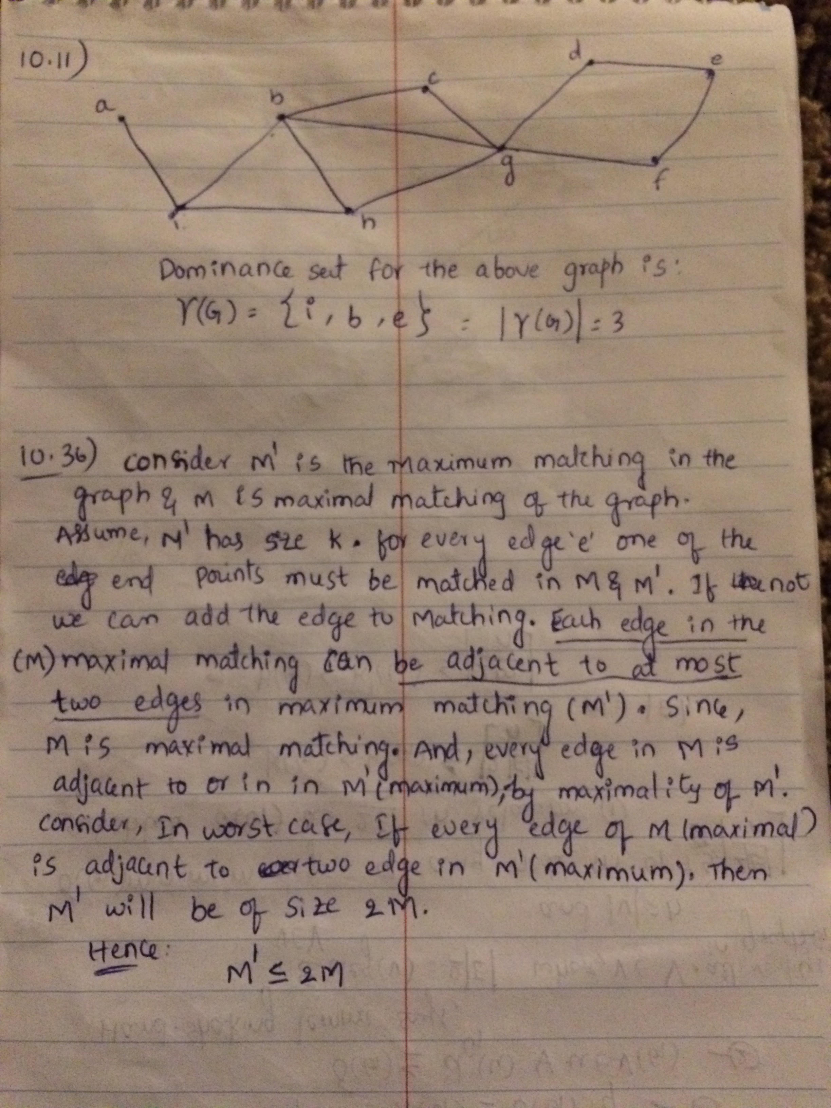

8)a)

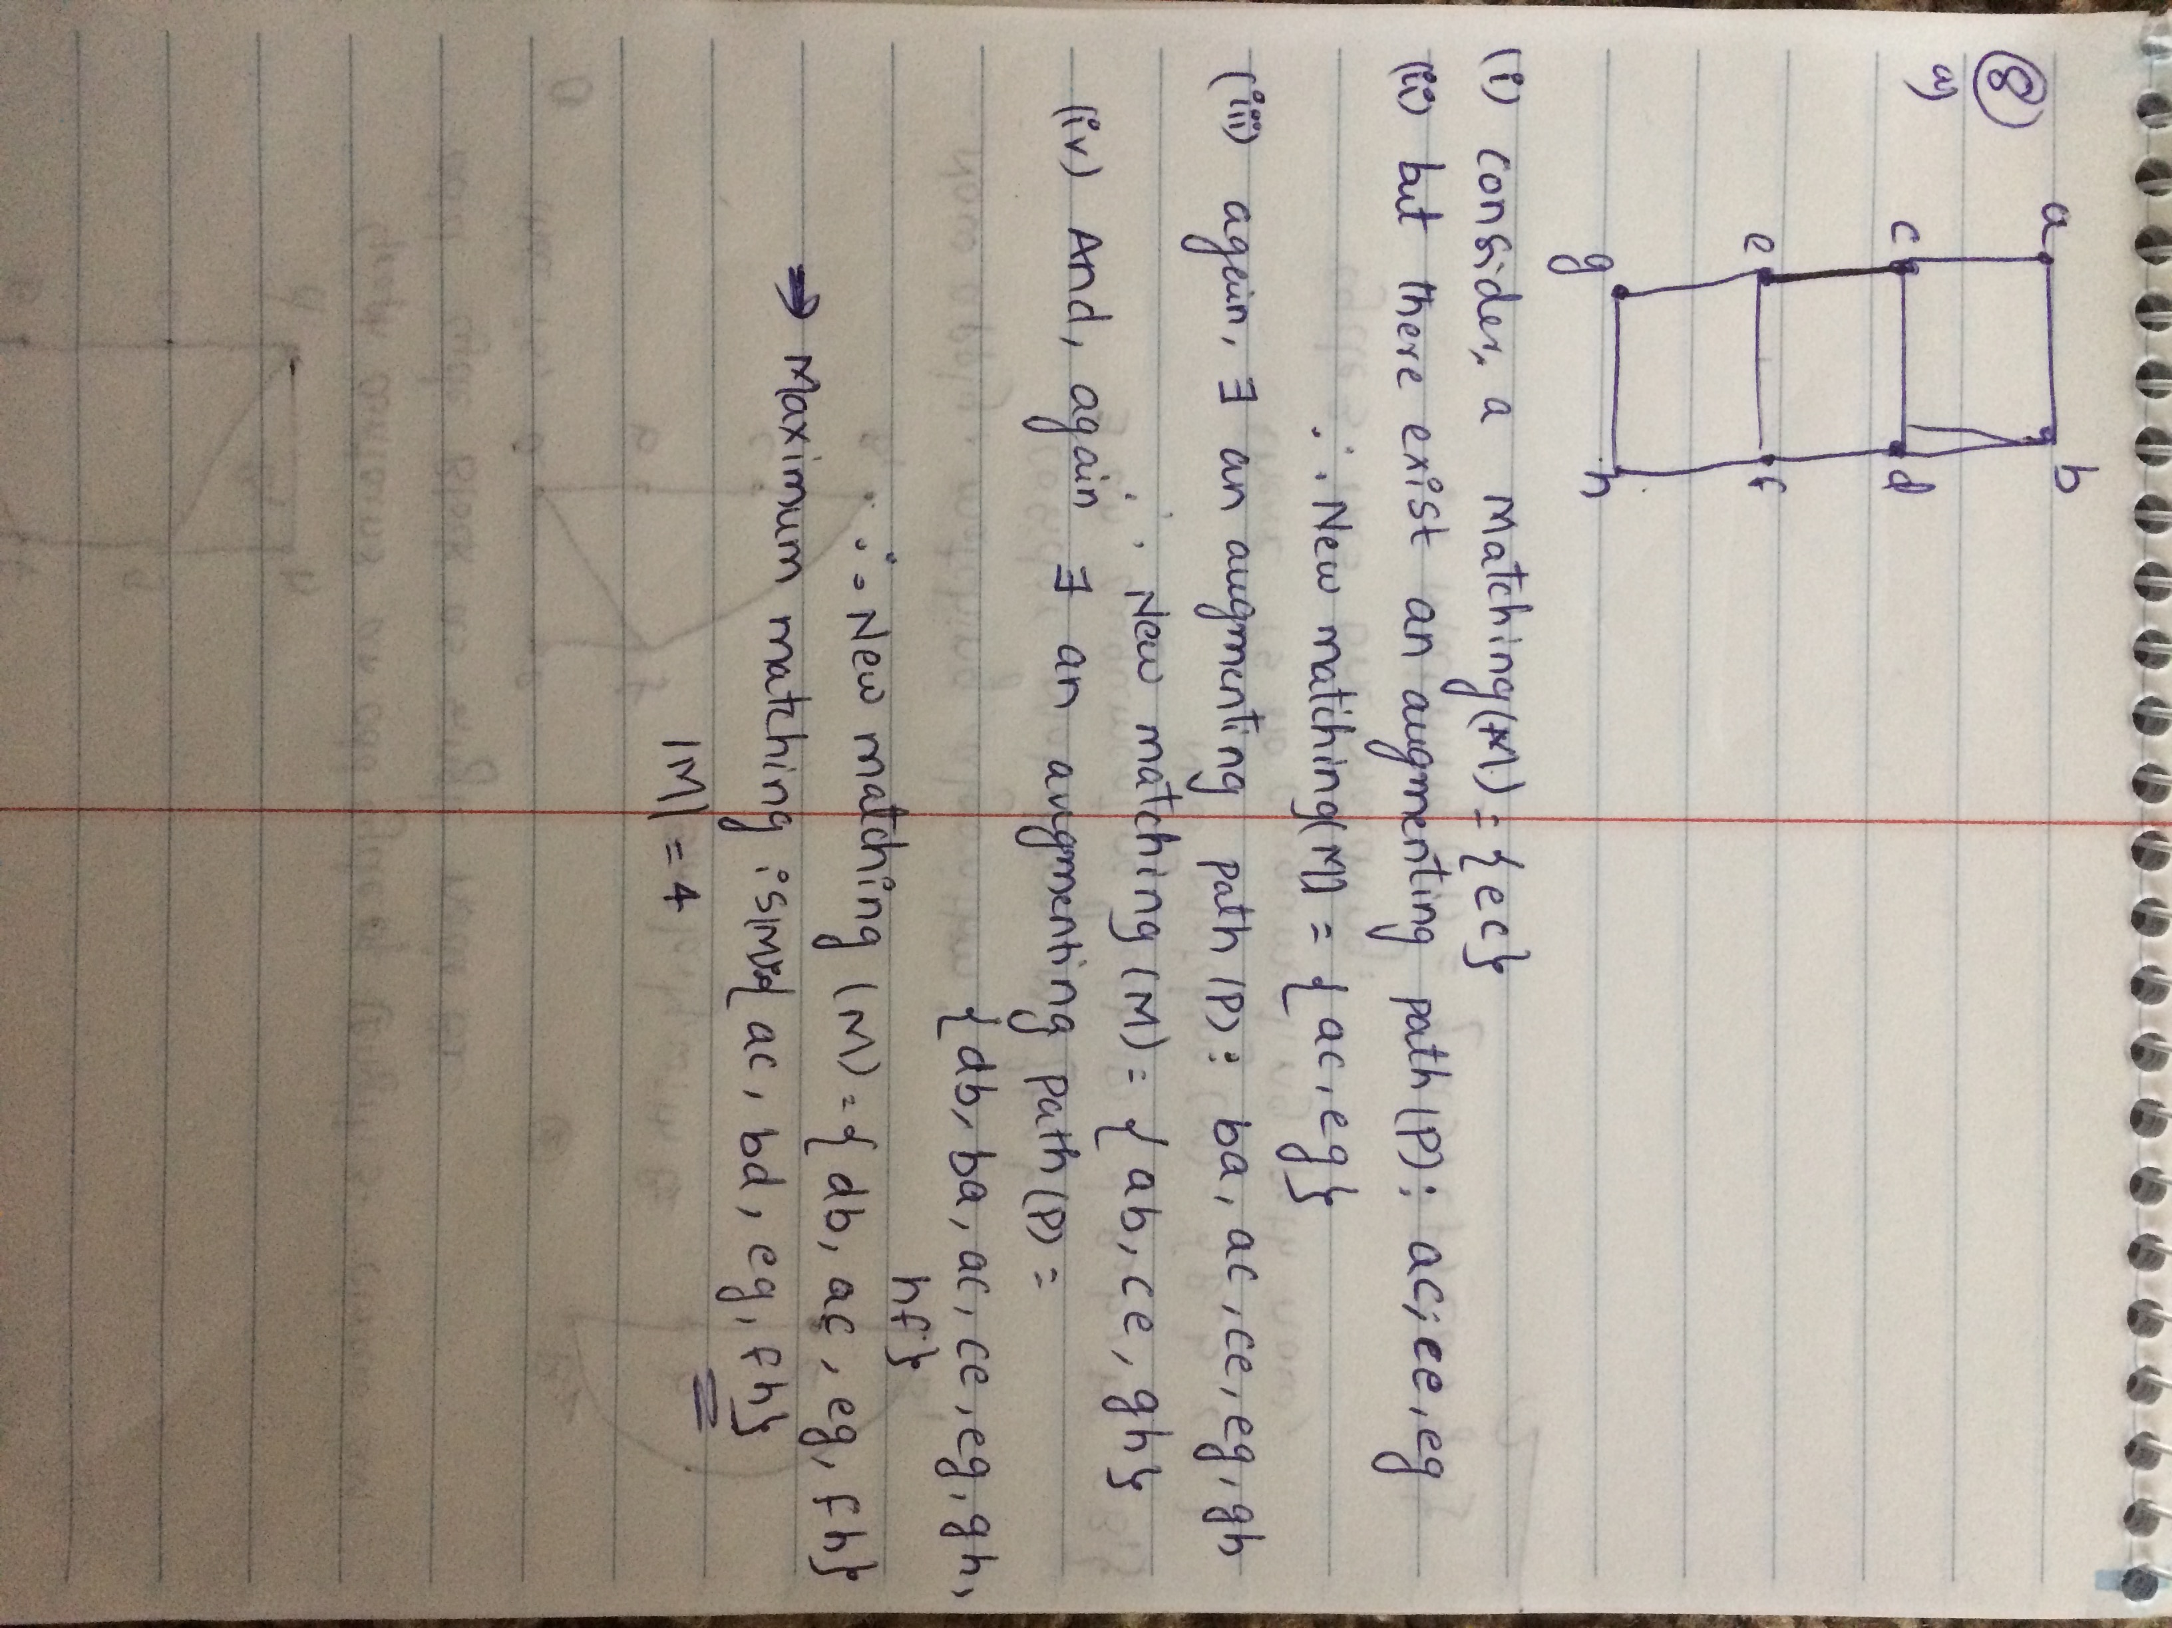

8)(b) Below graph has odd cycles in the graph, Consider each cycle as single node and redraw the graph then find matching set, add matching from cycle to set.

